**Report Team 41**

**Implemented Predicates :-**

(1) is_category(C)

True if C is a category

(2) categories(L)

True if L is a list of all available categories

(3) available_length(L)

True if there is any word in the data base with length L

(4) pick_word(W,L,C)

True if W is a word in the data base and L is its length and C is its category

(5) correct_letters(L1,L2,CL)

True if CL is a list of all common letters in L1 and L2

(6) correct_positions (L1,L2,CL)

True is CL is a list of all common letters in the same position in L1 and L2

(7) build_kb

Prints the welcome prompt and then calls bahy

(8) bahy

It is a loop , it asks the user to enter a word , if the word is done then it will exit the loop and print ‘Done building the words database...’ , else it will ask the user to enter the category of this word , then it will assert this category into the memory in the structure ‘category(C)’ and also assert the word into the memory in the structure ‘word(W,C)’ and calls bahy again

(9) play

Prints all the available categories and then calls bahy3 , bahy2 , structure ‘g(L1)’ , mg(L1)

(10) bahy3

It is a loop , it asks the user to chose a category , if it is an available category it will assert this category into the memory in the structure ‘cans(C)’ , else if will print ‘This category does not exist.’ and calls bahy3 again

(11) bahy2

It is a loop , it asks the user to choose a length for the word , if there is a word with the chosen length and category then

( it gets all the possible words with the chosen length and category and selects a random word from them and then asserts this word into the memory in the structure ‘wans(W)’ and then split the word into a list of letters and assert this list into the memory in the structure ‘las(Wl)’ and assert the length of the word into the memory in the structure ‘lenans(L)’ and calculates the number of guesses and assert it into the memory in structure ‘g(L1)’ and finally prompts that the game have started with this number of guesses )

, else

( prints ‘There are no words of this length.’ And calls bahy2 again )

(12) mg(L1)

It is a loop where L1 is the number of guesses remaining , it calls promt and the structure ‘tryial(T)’ where T is the word the used tried , then

( L1 (the number of guesses remaining) is equal to 1 and T is not the correct answer then it will print ‘You lost!’ and the game will end )

else ( if T is the correct word , it will print ‘You Won!’ and the game will end )

else ( it will display the correct letters and then will display the correct letters in correct positions and then decrease the number of guesses remaining (L1) by 1 and then retracts the structure ‘g(L1)’ and asserts the new number of remaining guesses into the memory in the structure ‘g(L2)’ and prints the remaining guesses number and retracts the structure ‘tryial(T)’ and finally calls mg(L2) )

(13) promt

It is a loop , it asks the user to guess a word of the choosen length , if the user entered a word of this length then ( it will be asserted into the memory in the structure ‘tryial(T)’ ) , else ( it will prompt that this word isn’t of the required length and prints the number of guesses and calls promt again )

(14) main

It calls build_kb and play and then retracts all the asserted structures earlier , so that at the next run the memory will be clear of any previous records

**Sample runs :-**

Win :

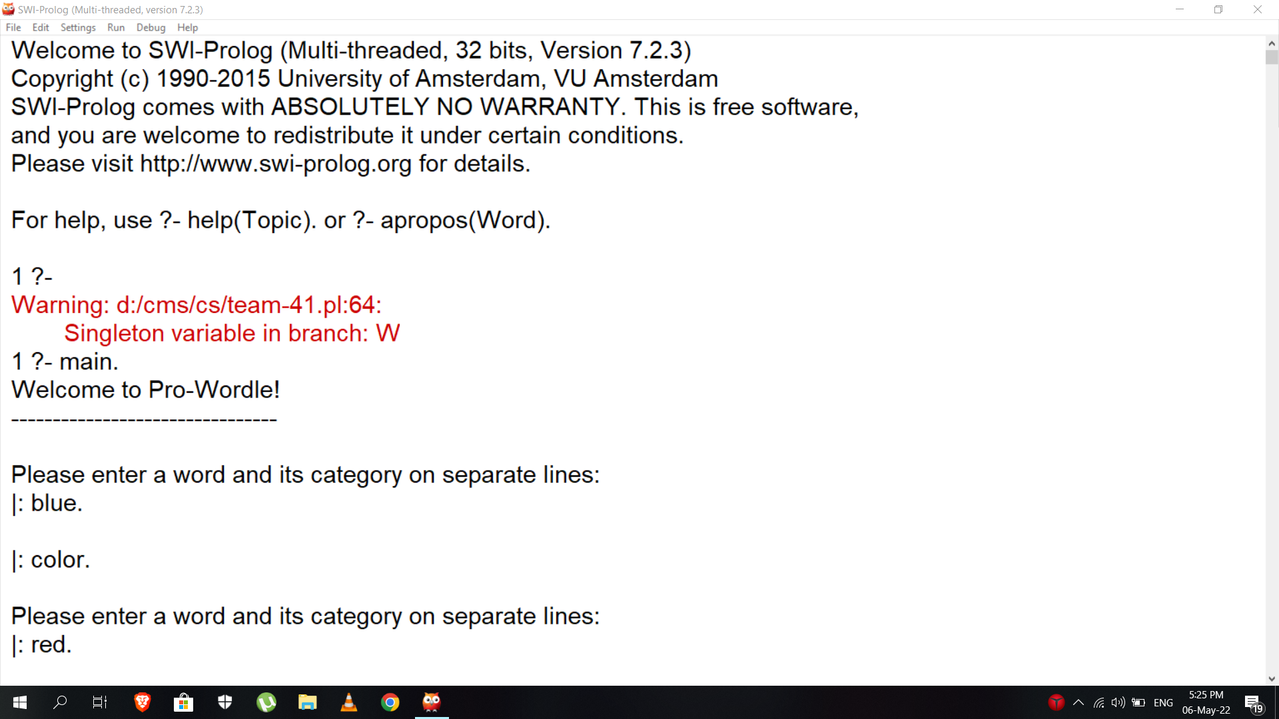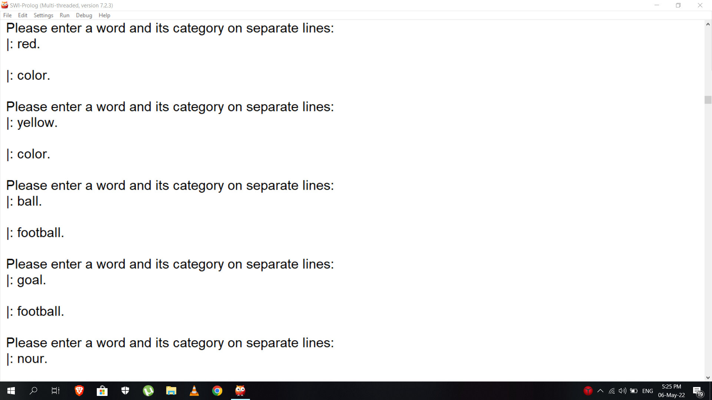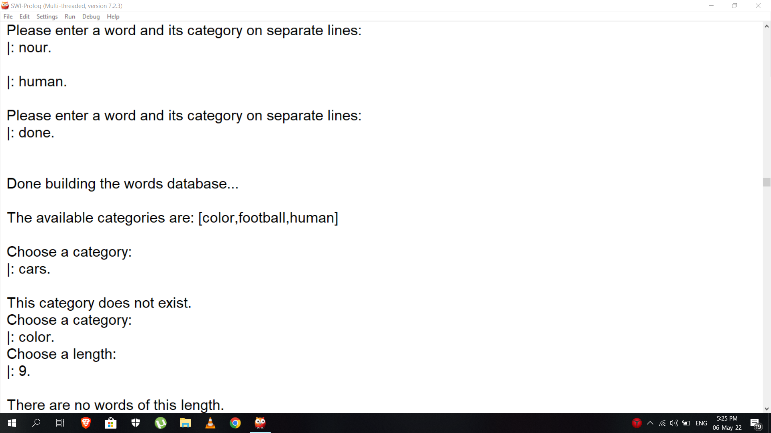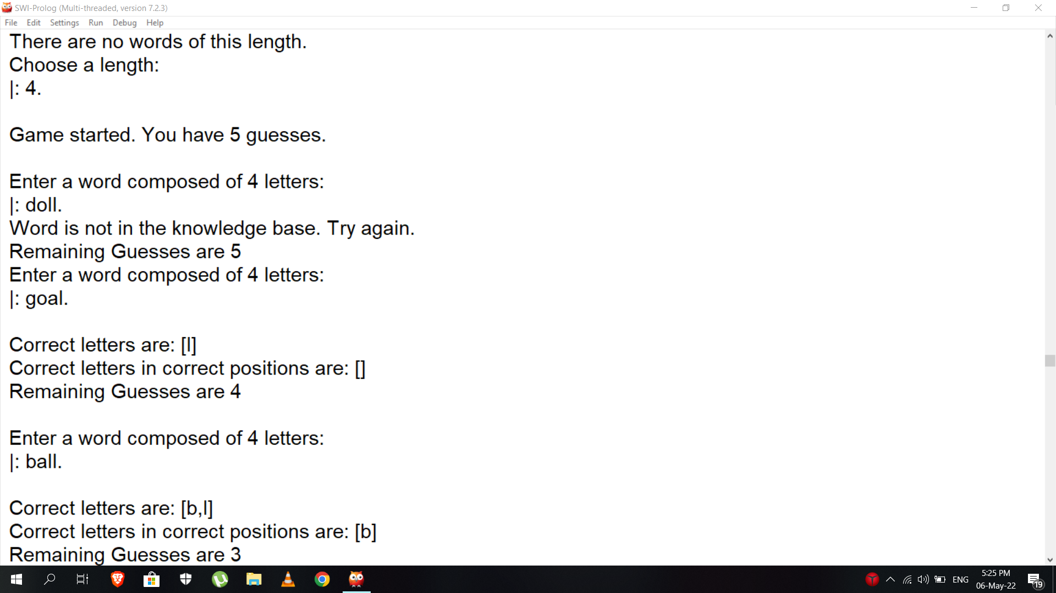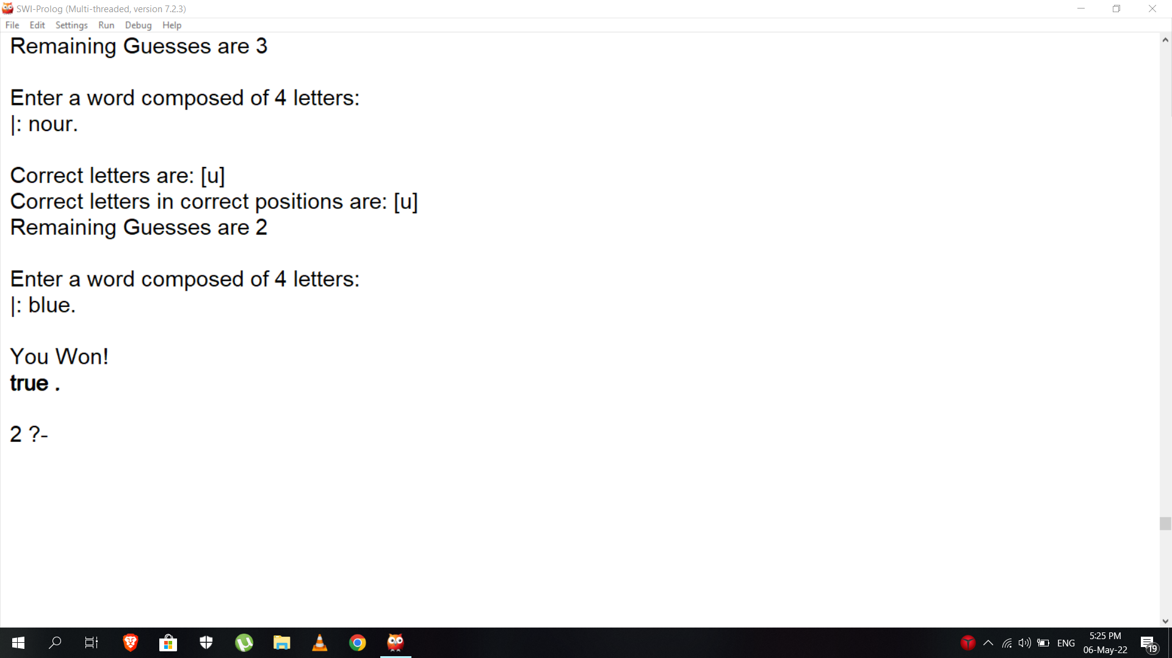

Lose :

